Functional specification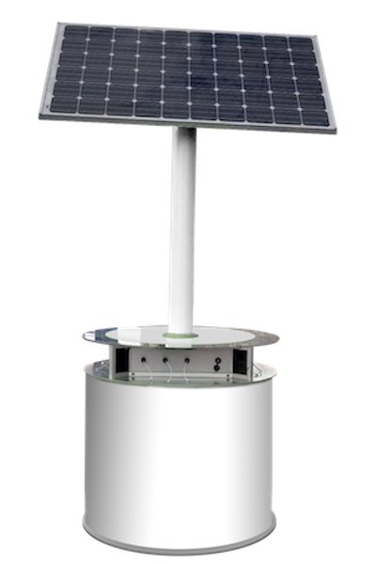

Solar driven mobile phone charging station

Background

The market for mobile phones is growing exponentially in many developing countries, including Africa. Access to electricity is, however, limited. Just like we have heard that people in some parts of the world can walk for hours to get water, getting to a place with electricity can take the same effort. Adding the time it takes to wait for the mobile to charge, this constitutes a huge ‘time tief’. Charging stations in remote areas are available, typically powered by polluting generators. **Small distributed solar systems would solve all these challenges.** Systems would typically be made available in kiosks or central community spots. The challenge is to make this a scalable and hence interesting business, benefiting every level from investors to local businesses (spearheads) offering the service to the end user. Key to success, we think, is digitalization, ensuring that **‘cash’ is flowing for every single charing service**. Many developing countries are already advanced when it comes to ‘mobile payment’ and the overall idea is to use this functionality to **allow the user to pay a small amount for the charging service, up front, with the very mobile to be charged**.

Overall technical description:

The solar system itself is not specified in detail here. Overall it consists of a solar panel whos only task is to charge a battery bank. The battery bank will, in turn, provide energy to the mobile phones, via several ‘USB outputs’. These ‘USB outputs’ will work only for mobile phones which are ‘cleared’, i.e. when charging has been paid for.

Anybody with a mobile phone (or with access to a web) can buy ‘charge time units’[1] and there will be two ways to ‘clear’ a phone/device for charging:

* Use one prepaid ‘charge time unit’ and pair the phone with the system directly (default/simplest method)[2]
* Use one prepaid ‘charge time unit’ to generate a code, with the following two options:
  + Enter the code on (any) phone and pair it, as above (as this code can be used by anybody with a web enabled phone, this will allow e.g. the person responsible for operating the system to provide services in exchange for cash)
  + Enter the code on (any) phone, pair it and ‘open’ a USB port for a fixed amount of time, e.g. 1h (this will allow any unit, e.g. solar lamps, torches, notepads, etc., i.e. not only phones to be charged)

Note: For all scenarios, the system will provide access to (USB) power for a short time to the end user, in order to be able to buy charge time or enter a code.

|  |  |  |
| --- | --- | --- |
| Functional requirement (what) | How | Dilemmas/decisions to be made |
|  |  |  |
| 'Frontend' (mobile solution) |  | Development platform? Whatever (PWA[3]) webapp framework gives the most speedy development (and has access to USB/Bluetooth API.) |
| Look & feel | Modern look…  ‘Hamburger’ menu at top left (‘animated’)  Name: mPower  (Sounds like empower. ‘m’ often used as first letter in Swahili, e.g. mPesa - mobile money and mZungo - white man)  Alternatives (to secure a domain name): mPowerStation, mPowerBank, mPowerLover  Other name ideas: ReNewGen/SunTopIt?/topITup?/ChargeIT | mPower.com domain taken, but not in use... |
| Menu options | If logged in:   * Logout * Charge * Buy charge time * New: Status/history * Learn how it works     If logged out   * Login * Charge (from code) * New: Status/(history) * Learn how it works |  |
| Welcome screen (not logged in) | Short description (+a more info button)  Buttons:   * ‘Login’ / ‘New user’ (sign up) * ‘Charge’ (with code)   Other info   * Map of nearest stations (and availability)? |  |
| When logged in screen | Info:  Show available charges  Buttons:   * 'Charge' / 'Generate code' * ‘Top up’ (buy more charge time units) | IDA: Top up   * vet ikke hvor mye top up er på andre ting enn mobilen, feks lampe, batteripakke * vanskelig å lade helt opp   Are: Med ‘top up’ mente jeg ‘fyll på penger’. Kan misforståes, ser jeg nå... |
| Charge screen (logged in) | (Handshake with local system)  Buttons: 'Use charge time'/'Enter code'   * Pair * Charge * Instructions (what port to connect to) * Status (‘battery status’ / time left)     Explanations:   * Status info: Charge status (estimated time remaining) or minutes remaining (for ‘general access’ option) | Pairing method. USB direct or Bluetooth? Bluetooth as first pri... |
| Charge screen (not logged in) | As above, but only the ‘Enter code’ option |  |
| Buy charge time screen | Show payment alternatives (boxes?)  Guide through the payment process   * Select payment alternative * Select number of charge units (‘credits’) |  |
| New: Status/history | Show ongoing charging sessions and remaining time  Show charge history |  |
| More info screen | Explain how it works:   * Buy units * Connect * Charge   (Pictograms?) | Suggestions from Lawrence:   * Admin transactions screen option * One display which shall various icons with a scroll button for searching needed app |
|  |  |  |
| Admin Web |  | Separate App or special login with the above? |
| System overview | Location of systems (map/coordinate)  Status of each system (on/off, online/offline, etc.)  Performance of each system   * Charge statistics * Battery health and current capacity * Etc. | Is it possible to ‘pull’ small amounts data from systems not connected, through the connected phone? (Or maybe the operators phone?!) |
|  |  |  |
| 'Backend' (cloud database) |  | Select backend: Any (as long as it can also 'talk' with the local system. |
| Data from WebApp |  |  |
| Users | Name++ (Username, PW, etc.)  Charges available (info from the two below) |  |
| Charges | Date, local system ID, user |  |
| Purchases | Date, bank system, user ID, amount, charge units, |  |
| Systems | ID, location, contact data (name, phone, etc.), date (taken into use) | Managed directly in the DB or via the WebApp? (Admin Web) |
| Data from system |  | Do we need to connect the system?  The system should be fully functional offline (based on the principle that payment is done by the mobile), but we should plan for a default connected solution. |
| System info | ID, Status (online/offline), Battery health(?), Total energy provided (info from the below) |  |
| Energy balance | Date, time (hh:mm), Current to battery, Current from battery | Data once per hour enough? |
|  |  |  |
| Local system |  |  |
| HW | All inclusive PCB, consisting of:   * Processing unit (controller) with suitable processing power and memory (and with integrated Wi-fi, bluetooth and ‘GSM modem’) * Solar charge regulator * Battery protector * 12V to 5V DC/DC converter (to feed processing unit and USB ‘outputs’) * 10 USB ‘outputs’ with current limiters and sensing   Block diagram as follows:  TBD | HW platform? ARM Cortex?  Display/keypad? NEI |
| SW functionality ('firmware') |  |  |
| * PV charge controller | Regulate the voltage coming from the solar panel to a correct charging voltage/current for the battery (bulk, float, etc.) |  |
| * Metering | Measure energy from PV to battery  Measure energy from battery to USBs | Every second internally, while once an hour reported externally (to the cloud)? |
| * Handshake with mobile |  | Pairing method: Bluetooth  Mobile cleared for a time period? YES |
| * Battery protection | Disconnects consumers from battery, if too low voltage |  |
| * Put live to dead phone |  | Time window? YES (2min) |

Overview of payment solutions:

(See: <https://www.mckinsey.com/industries/financial-services/our-insights/mobile-financial-services-in-africa-winning-the-battle-for-the-customer> for a good intro)

|  |  |  |  |
| --- | --- | --- | --- |
|  | Coverage | General info | API info |
| Generic VISA/Mastercard | Global | <https://en.wikipedia.org/wiki/E-commerce_payment_system> | <https://developer.visa.com/> |
| PayPal | Global | <https://en.wikipedia.org/wiki/PayPal> | https://developer.paypal.com/docs/api/overview/# |
| M-PESA | Kenya/Tanzania | <https://en.wikipedia.org/wiki/M-Pesa> | <https://www.safaricom.co.ke/business/corporate/m-pesa-payment-services/m-pesa-api> |
| Mobi |  | https://www.mobicashonline.com/ |  |

Rule of thumb:

A 2000mAh battery charged by 2A USB takes ~45-60 minutes

(2000mAh*3,76V = ~7.4Wh / 5V*2A*1h = 10Wh)

**Similar products to give us some ideas (move to Sh.p.):**

Web:

* <http://iubao.com/product/battery%20charging%20Kiosk/273.html> This can also be one of our sales products to the institutions in the future

Example pictures:

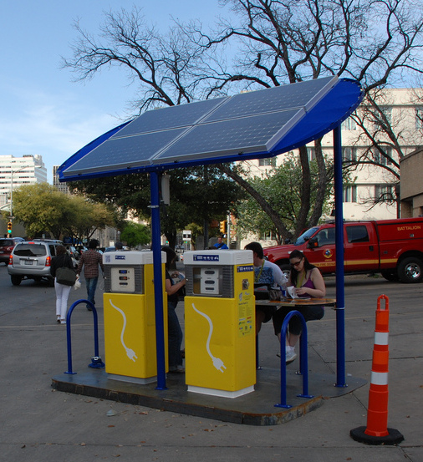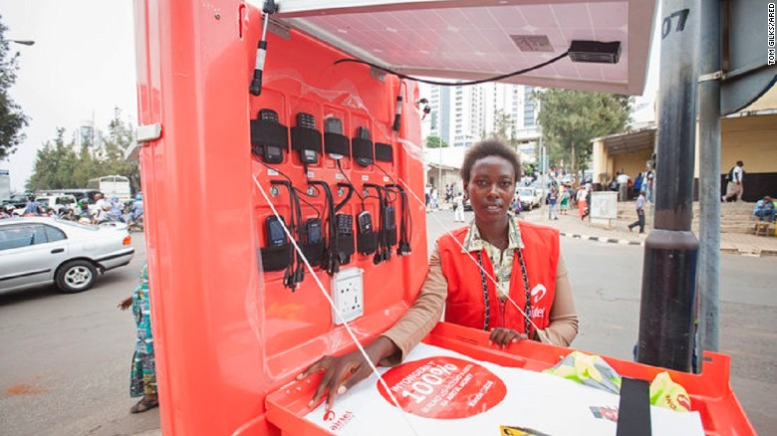

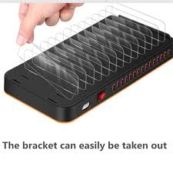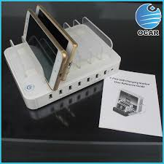

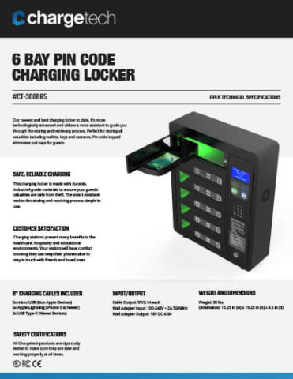

*This picture looks very nice in the way that the phones are being kept inside the system which is much okay with the type of our expected venue of operation where roads are in maram with a lot if dust. Also the system operates on codes which goes with some of the ideas brother Are brought in this document as mentioned above.*

1. Assumed price: ~0,1 USD
2. Ideally this should be fully automatic (plug and play), but will probably require some ‘pairing activity’
3. Progressive Web Application